JOB DESCRIPTION & PERSON SPECIFICATION
Director Area: Fire & Rescue |  | Job Ref Number: 04006
Service Area: Central Support |  | Grade: G6
Job Title: Continuous Improvement Support Officer

PURPOSE OF JOB:

To support the Continuous Improvement Manager in their duties, across the Service in a broad range of activities supporting Lincolnshire Fire & Rescue priorities and objectives thereby improving efficiency and effectiveness

TEAM STRUCTURE:

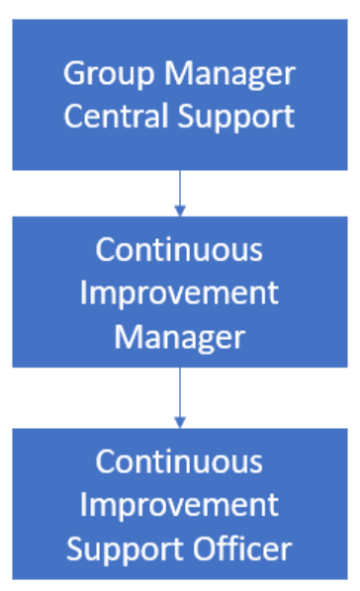
MAIN DUTIES:
1. | To provide project support across a broad range of service projects to continuously improve effectiveness.
2. | Support the development and production of all project documentation.
3. | Ensure that project documentation, such as action, decision, risk and issue logs remain up to date, relevant, accurate and compliant with council’s corporate standards.
4. | Facilitate the delivery of key team, service area, project and programme meetings, including scheduling, preparing agendas, writing accurate minutes and actions and tracking actions.
5. | Proactively monitor project and continuous improvement actions and progress, including appropriate escalations, or where possible, proactive resolution of issues.
6. | Monitor the development, production, and actions of Equality & Impact Assessments, Data Protection Impact Assessments and Sustainability Impact Assessments for all projects.
7. | For the creation of options appraisals, business cases and insight work, support research and benchmarking activities, baselining in order to identification best practice and propose a range of potential options/solutions that could considered and adopted.
8. | Support and arrange training across the organisation where new systems are being rolled out as part of a project. This would also involve ensuring any training provided is supported by relevant and up to date training materials and guidance.
9. | Support research activities for the development of process mapping flows for ‘as is’ and ‘to be’ models when working with Project Managers and in general, across continuous improvement tasks and requests. At times this may involve interviewing employees and creating process maps.
10. | Create surveys using tools such as Microsoft forms and Slido. From data received; analyse results, present findings, conclusions and recommendations for consideration.
11. | Provide administrative support to the Continuous Improvement Manager. Areas include; event and training coordination, minute taking, monitoring and maintenance of the annual service plan, ad-hoc service reviews, service improvement plans and fire standards.
12. | Support the co-ordination and analyse partnerships delivery, review health checks and identifying efficiencies and improving productivity to support service delivery.
13. | Undertake any other administrative tasks in order to support Fire & Rescue events management such as Medal Ceremony and Recognition Awards. Manage the coordination of other fire & rescue events.
14. | Collate and maintain a central repository for surveys and consultations received, ensuring records are regularly updated with key milestones, progress updates, returns and relevant information.
PERSON SPECIFICATION:
Requirements | Where identified* | Essential | Desirable
Associate Project  Manager Level 4 qualification or educated to A level or equivalent. | A | x
Excellent level of IT literacy to be able to use self-service, digital user platforms and applications and MS Office applications. | A | x
Knowledge & awareness of project management tools and techniques. | A/I | x
Experience of working in a PMO environment and/or supporting projects. | A/I | x
The ability to collate, interpret and present data. | A/I | x
Proven ability to manage your own workload and multiple tasks simultaneously. | A/I | x
Able to produce a range of written materials which are accessible to a range of audiences. | A/I | x
Demonstrating problem solving capabilities. | A/I | x
Effective written, presentation and verbal skills. | A/I | x
The ability to respond quickly and positively to changing priorities. | A/I | x
Strong organisational skills to manage competing priorities. | A/I | x
Effective interpersonal skills and the ability to build strong professional relationships. | A/I | x
Strong facilitation skills and ability to minute and follow up on actions from project meetings/workshops. | A/I | x
Experience in stakeholder engagement, including consulting staff and interested parties. | A/I | x
Knowledge of Fire Service strategies, policies, procedures and issues affecting the Fire Service on a local, regional and national level. | A/I |  | x
Experience of benefits management, capturing and analysing benefits, and assessing the impact and ultimate realisation.
Experience of risk and issue management. | A/I | x
Excellent customer service skills and able to manage expectations when dealing with key internal and external stakeholders around projects and programme delivery. | A/I | x
Ability to work as a proactive member of the Central Support Team. | A/I |  | x
Committed to personal development, and keeping up to date with emerging initiatives. | A/I | x
*A = Application form T = Test/Assessment I = Interview P = Presentation

GENERAL

The postholder is required to take personal responsibility for contributing to organisational transformation and changes in ways of working, maximising the benefits and efficiencies for both internal and external customers, including the promotion and use of self–service to achieve maximum cost effectiveness.

The postholder is expected to work to the Lincolnshire County Council Core Values and Behaviours and to carry out the duties in accordance with Lincolnshire County Council policies.

Other Duties - The duties and responsibilities in this job description are not exhaustive. The post holder may be required to undertake other duties within the general scope of the post. Any such duties should not substantially change the general character of the post. Duties and responsibilities outside of the general scope of this grade of post will be with the consent of the post holder.

Safeguarding -. All employees need to be aware of the possible abuse of children and vulnerable adults and if you are concerned you need to follow the Lincolnshire County Council Safeguarding Policy. In addition employees working with children and vulnerable adults have a responsibility to safeguard and promote the welfare of children and vulnerable adults during the course of their work.

